HRSA EHB USER GUIDE
SF-424 R&R Application User Guide

Last updated on: 05/20/2014

Contents
Contents 2
List of Figures 4
1. Accessing the Application 5
2. Basic Information 5
2.1. SF-424 R&R Forms 5
2.1.1 SF-424 R&R – Part 1 5
2.1.2 SF-424 R&R – Part 2 6
2.2. Key Contact 7
2.3. Senior/Key Person Profile 7
2.4. Project/Performance Site Location(s) 8
3. Budget Information 8
3.1. Section A 8
3.1.1 Add New Senior/Key Person to Budget Period 9
3.1.2 Update Senior/Key Person Already Added to Budget Period 9
3.2. Section B 9
3.2.1 Add Other Personnel to Budget Period 10
3.2.2 Update Other Personnel Already Added to Budget Period 10
3.3. Section C 11
3.3.1 Add Equipment to Budget Period 11
3.3.2 Update Equipment Already Added to Budget Period 11
3.4. Section D 12
3.5. Section E 12
3.6. Section F 12
3.7. Section G – J 13
3.7.1 Add Indirect Costs to Budget Period 13
3.7.2 Update Indirect Costs Already Added to Budget Period 13
3.8. Section K 14
4. Other Information 14
4.1. Assurances 14
4.2. Other Project Information 14
4.3. Appendices 15
5. Program Specific Forms 15
6. Review and Submit 16
6.1. Review 16
6.2. Application - Submit 16

List of Figures
Figure 1: Banner - Grants.gov Applications Pending Validation 5
Figure 2: Banner - Success 5
Figure 3: Address Type Fields - Mailing Address 6
Figure 4: Address Type Fields - Physical Address 8
Figure 5: Senior Key Person - Add Button and Update Links 9
Figure 6: Other Personnel - Add Button and Update Links 10
Figure 7: Equipment Description - Add Button and Update Links 11
Figure 8: Indirect Costs - Add Button and Update Links 13

Note regarding the SF-424 R&R SHORT Application:
The following forms do not apply to SF 424 R&R Short Application:
- Project/Performance Site Location(s)
- Senior/Key Person Profile
- Budget Sections A-K
- Other Project Information

Accessing the Application
- Click the Tasks tab in the Top Navigation Menu.
- On the Pending Tasks – List page, in the Left Navigation Panel, click Grant Applications under the Requests heading.
- For the application you want to edit, click the Edit link for the application you want to edit.
If the Application that you’re looking for was entered in Grants.gov, you first need to validate it by clicking the Validate link on the Grants.gov Applications Pending Validation Banner.
Figure 1: Banner - Grants.gov Applications Pending Validation
You can access the individual entry forms for an SF-424 R&R application by clicking the section name links in the Left Navigation Panel or the Update link on the Application Status Overview page.
(For this exercise, we’ll use the links in the Left Navigation Panel.)
Note Regarding Certain Errors on Some of the Forms:
- Usually when you click the Save and Continue button at the bottom of a form, if there are critical errors on the form, the errors will be displayed, and the system will NOT automatically display the next form.
- However, for some types of errors, the system WILL automatically display the next form, along with a Success banner, indicating that the previous section (form) was SAVED successfully.
Note, that, this type of Success Banner will also state that the form status of the previous section is NOT Complete.
Figure 2: Banner - Success
When you return to the previous form, the page will display the error(s).

Basic Information

SF-424 R&R Forms
Click SF-424 R&R under the Basic Information heading in the Left Navigation Panel to display the SF-424 R&R – Part 1 page.

SF-424 R&R – Part 1
The SF-424 R&R - Part 1 page allows you to enter organizational information.
- Specify the Applicant Information that’s not already populated.
Under Mailing Address, if you change the Address Type from Domestic Address to an International Address or vice versa, you have to click the Refresh button to display the corresponding address fields.
Figure 3: Address Type Fields - Mailing Address
- Under the “Person to be contacted on matters involving this application” heading, click the button.
- On the Point of Contact - Add page
- Select an existing contact and click the Add Selected Person button
- Click the button above the “Choose Person to Add as POC” heading to add a new contact.
- On the next page, edit/enter the Point of Contact information, click the Save and Continue button, then click the Confirm button on the following confirmation page to return to the SF-424 R&R - Part 1 page.
- Click the Save and Continue button on the SF-424 R&R - Part 1 page to progress to the next form.

SF-424 R&R – Part 2
The SF-424 R&R - Part 2 page allows you to enter miscellaneous information regarding your application (Dates, Estimated Funding, Authorized Representative, etc.).
Click the SF-424 R&R - Part 2 tab on the SF-424 R&R– Part 1 page to display the SF-424 R&R– Part 2 page, if you’re not already on it.
- Specify the information that’s not already populated.
- Under the “Project Director/Principal Investigator” heading, click the button.
- On the Project Director/Principal Investigator – Add page:
- Select an existing representative and click the Add Selected Person button.
- Click the button above the “Choose Person to Add as PD” heading, add a new Project Director/ Principal Investigator.
- On the next page, edit/enter the Project Director/Principal Investigator information, click the
Save and Continue button, then click the Confirm button on the following confirmation page to return to the SF-424 R&R - Part 2 page.
- Under the “Authorized Representative” heading, click the button.
- On the Authorizing Official - Add page:
- Select an existing representative and click the Add Selected Person button.
- Click the button to add a new representative.
- On the next page, edit/enter the Authorizing Official information, click the
Save and Continue button above the “Choose Person to Add as AO” heading, then click the Confirm button on the following confirmation page to return to the SF-424 R&R - Part 2 page.
If you requested a new AO in step 3a:
- An email will be sent to the user that you requested as an AO, containing instructions as to how to register as an AO in the EHB. Once the user is registered, the user will become available to be selected as the AO.
- The requested AO will not appear in the SF-424 R&R – Part 2 form as the Authorized Representative.
- You will still have to go back and select an existing representative as the AO.
- Use the Attach File buttons on the relevant headings, and follow the usual procedure to attach applicable documents, as necessary.
- Click the Save and Continue button on the SF-424 R&R- Part 2 page to progress to the next form.

Key Contact
The Key Contact page allows you to specify the Key Contact for the application.
Click Key Contact under the Basic Information heading in the Left Navigation Panel to display the Key Contact page.
- Under the “Key Contact Information” heading, click the button.
- On the Key Contact - Add page
- Select an existing contact and click the Add Selected Person button
- Click the button above the “Choose Person to Add as Key Contact” heading to add a new contact.
- On the next page, edit/enter the Key Contact information, click the Save and Continue button, then click the Confirm button on the following confirmation page to return to the Key Contact page.
- Click the Save and Continue button on the Key Contact page to progress to the next form.

Senior/Key Person Profile
The Senior/Key Person page allows you to enter information regarding the Key people for the grant.
Click Senior/Key Person Profile under the Basic Information heading in the Left Navigation Panel to display the Senior/Key Person Profile page.
The “Project Director/Project Investigator” heading will list the Project Director/Project Investigator that was added in
the SF-424 R&R – Part 2 form.
If you click the Update link under the heading, the only thing that you can update is to add Credential information.
If you need to completely update the Project Director/Project Investigator, go to the SF-424 R&R – Part 2 form rather than click the Update link under its heading on this page.
- Under the “Senior/Key Person Profile” heading, click the button.
- On the Senior/Key Person - Add page
- Select an existing contact and click the Add Selected Person button
- Click the button above the “Choose Person to Add as Senior/Key Person” heading to add a new contact.
- On the next page, edit/enter the Senior/Key Person information, click the Save and Continue button, then click the Confirm button on the following confirmation page to return to the Senior/Key Person Profile page.
- Use the Attach File buttons on the relevant headings, and follow the usual procedure to attach applicable documents, as necessary.
You must attach a biographical Sketch of the PD/PI.
- Click the Save and Continue button on the Senior/Key Person Profile page to progress to the next form.

Project/Performance Site Location(s)
The Project/Performance Site Location(s) page allows you to specify the main sites regarding the grant.
You must enter at least one site, which will be the Primary Project/Performance Site.
Click Project/Performance Site Location(s) under the Basic Information heading in the Navigation Panel to display the Project/Performance Site Location(s) page, if you’re not already on the page.
- Click the button.
- On the Project/Performance Site Location – Add page, enter the requested information and click the
Save and Continue button.
Under Physical Address, If you change the Address Type from Domestic Address to an International Address or vice versa, you have to click the Refresh button to display the corresponding address fields.
Figure 4: Address Type Fields - Physical Address
- Repeat steps 1-2 to add additional Project/Performance Sites.
- Click the Save and Continue button on the Project/Performance Site Location(s) page to progress to the next form.

Budget Information

Section A
Section A allows you to request funds for Senior/Key People.
Click Section A under the Budget Information heading in the Left Navigation Panel to display the Section A page, if you’re not already on the page.
Enter the requested information for Senior/Key People for any of the 5 Budget Periods, as applicable:
- You MUST enter the requested information for at least Budget Period 1
- Enter the Start and End Dates of the Budget Period.
- You MUST enter the Start and End Dates for All Budget Periods, for which you will request funds.
These Budget Periods are herein referred to in the other Budget Sections as “all the Budget Periods that are applicable”.
- Add or update the Senior/Key People to work in the Budget Period, along with their personal and financial information, as per the sub-topics, below.
After you add or update the Senior/Key People, and return to the Section A page, the financial fields for the Budget Period will reflect your entries.
Figure 5: Senior Key Person - Add Button and Update Links
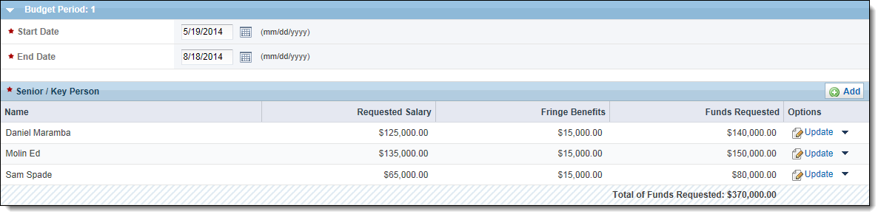
- After you finish entering the information for all the specified Senior/Key People, for all the Budget Periods that are applicable, click the Save and Continue button to progress to the next form.

Add New Senior/Key Person to Budget Period
- Click the button in the Budget Period’s “Senior/Key Person Profile” heading, to add a new Senior/Key Person for the Budget Period.
- On the Senior/Key Person – Select page:
- Select a listed Key Person, and click the Add Selected Person button.
- Add another Senior/Key Person by clicking the Add New Person button.
- On the Senior/Key Person – Add page,
- Enter/edit the personal information such as the name fields, and Project Role.
- Enter/edit the financial information such as the salary and benefit fields, and the month fields.
- Click the Save and Continue button to return to the Section A page.

Update Senior/Key Person Already Added to Budget Period
- Click the Update link for a Senior/Key Person already added for the Budget Period
(i.e., listed under the Budget Period’s “Senior/Key Person Profile” heading).
- On the Senior/Key Person – Update page,
- Enter/edit the personal information such as the name fields, and Project Role.
- Enter/edit the financial information such as the salary and benefit fields, and the month fields.
- Click the Save and Continue button to return to the Section A page.

Section B
Section B allows you to request funds for Other Personnel (i.e., other than the Senior/Key People).
Click Section B under the Budget Information heading in the Left Navigation Panel to display the Section B page, if you’re not already on the page.
Enter the requested information for Other Personnel, for all the Budget Periods that are applicable:
Unlike the Senior/Key People who are individually added or updated, multiple Other Personnel are added or according to Project Role.
- Add or update the types of Other Personnel to work in the Budget Period, along with the related financial information, as per the sub-topics, below.
After you add or update the Other Personnel, and return to the Section B page, the financial fields for the Budget Period will reflect your entries.
Figure 6: Other Personnel - Add Button and Update Links
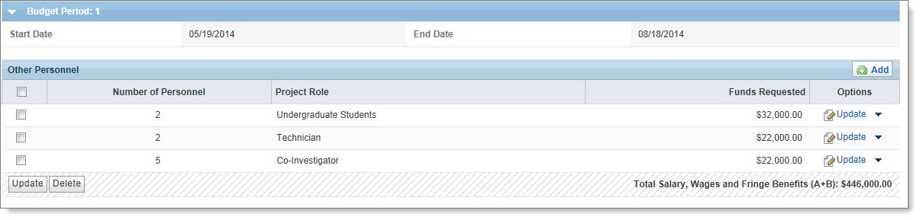
- After you finish entering all the types of Other Personnel, for all the Budget Periods that are applicable, click the Save and Continue button to progress to the next form.

Add Other Personnel to Budget Period
- Click the button in the Budget Period’s “Other Personnel” heading, to display the Other Personnel - Add page.
- Select a Project Role.
- Enter the number of Personnel for the Project Role.
- Enter the month fields, and the salary and benefit fields for the Project Role.
- Use the other rows on the page, and repeat steps a through c to add Other Personnel for additional Project Roles.
If you need you add more Project Roles, and you don’t have enough rows on the page, click the button in the “Other Personnel - Budget Period n” heading.
- When you’re finished adding Project Roles, click the Save and Continue button to return to the Section B page.

Update Other Personnel Already Added to Budget Period
- To update the Funds Requested for Other Personnel:
- For a single Project Role,
Click the Update link for the Project Role in the Options column of the Budget Period’s “Other Personnel” heading.
- For multiple Project Roles,
Select the Project Roles that you wish to update under the Budget Period’s “Other Personnel” heading, and click the Update button below the displayed Project Roles.
- On the subsequently displayed Other Personnel - Update page,
Edit the fields for the listed Project Role(s).
- Click the Save and Continue button to return to the Section B page.

Section C
Section C allows you to request funds for Equipment.
Click Section C under the Budget Information heading in the Left Navigation Panel to display the Section C page, if you’re not already on the page.
Enter the requested information for Equipment, for all the Budget Periods that are applicable:
- Add or update the Equipment in the Budget Period, as per the sub-topics, below.
After you add or update the Equipment, and return to the Section C page, the financial fields for the Budget Period will reflect your entries.
Figure 7: Equipment Description - Add Button and Update Links
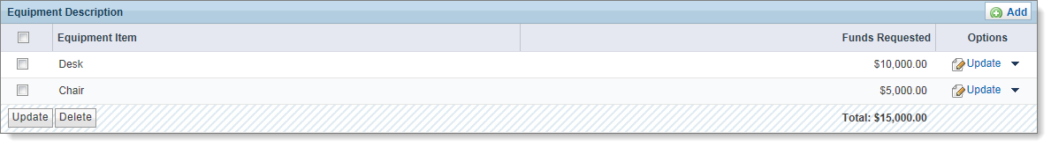
- After you finish entering all the Equipment, for all the Budget Periods that are applicable, click the
Save and Continue button to progress to the next form.

Add Equipment to Budget Period
- Click the button in the Budget Period’s “Equipment Description” heading, to display the Equipment - Add page.
- For each piece of Equipment:
- Enter the name of the Equipment Item.
- Enter the Funds Requested ($)
If you need you add more Equipment, and you don’t have enough rows on the page, click the button in the “Equipment - Budget Period n” heading.
- When you’re finished adding Equipment, click the Save and Continue button to return to the Section C page.

Update Equipment Already Added to Budget Period
- To update the Funds Requested for piece of Equipment:
- For a single piece of Equipment,
Click the Update link for the Equipment in the Options column of the Budget Period’s “Equipment Description” heading
- For multiple pieces of Equipment,
Select the pieces of Equipment that you wish to update under the Budget Period’s “Equipment Description” heading, and click the Update button below the displayed Equipment.
- On the subsequently displayed Equipment - Update page,
Edit the fields for the displayed piece of Equipment.
- Click the Save and Continue button to return to the Section B page.

Section D
Section D allows you to request funds for Travel.
Click Section D under the Budget Information heading in the Left Navigation Panel to display the Section D page, if you’re not already on the page. Section D is for entering
- For all the Budget Periods that are applicable, enter the Funds Requested for:
- Domestic Travel Costs (Incl. Canada, Mexico and U.S. Territories)
- Foreign Travel Costs
To calculate totals at any time, click the Save button.
- Click the Save and Continue button to save your work and progress to the next form.

Section E
Section E allows you to request funds for Training.
Click Section E under the Budget Information heading in the Left Navigation Panel to display the Section E page, if you’re not already on the page.
- For all the Budget Periods that are applicable,
- Enter the Funds Requested for all the pertinent Participant/Trainee Support Costs.
- Enter the number of Participants/Trainees.
To calculate totals at any time, click the Save button.
- Click the Save and Continue button to save your work and progress to the next form.

Section F
Section F allows you to request funds for Other Direct Costs.
Click Section F under the Budget Information heading in the Left Navigation Panel to display the Section F page, if you’re not already on the page.
- For all the Budget Periods that are applicable, enter the Funds Requested for all the Other Direct Costs.
To calculate totals at any time, click the Save button.
- Click the Save and Continue button to save your work and progress to the next form.

Section G – J
Section G – J, for each Budget Period:
- Summarizes all the Direct Costs that you have requested on the previous forms (Sections A – F).
- Allows you to request funds for Indirect Costs.
- Totals all the Direct and Indirect Costs.
Click Section G – J under the Budget Information heading in the Left Navigation Panel to display the Section G – J page, if you’re not already on the page.
Enter the requested information for the Indirect Costs, for all the Budget Periods that are applicable:
- Add or update the Indirect Costs in the Budget Period, as per the sub-topics, below.
After you add or update the Indirect Costs, and return to the Section G - J page, the financial fields for the Budget Period will reflect your entries.
Figure 8: Indirect Costs - Add Button and Update Links
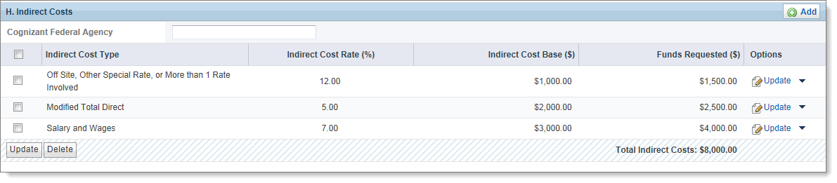
- After you finish entering all the Indirect Costs, for all the Budget Periods that are applicable, click the
Save and Continue button to progress to the next form.

Add Indirect Costs to Budget Period
- Click the button in the Budget Period’s “Indirect Costs” heading, to display the Indirect Cost - Add page.
- For each Indirect Cost:
- Select the Cost Type from the dropdown.
- Enter the financial information for the Cost Type (e.g., Indirect Cost Rate, Indirect Cost Base, and Funds Requested).
- Enter the Funds Requested ($)
If you need you add more Indirect Costs, and you don’t have enough rows on the page, click the button in the “Indirect Cost - Budget Period n” heading.
- When you’re finished adding the Indirect Costs, click the Save and Continue button to return to the Section G - J page.

Update Indirect Costs Already Added to Budget Period
- To update the Funds Requested for piece of Equipment:
- For a single Indirect Cost,
Click the Update link for the Indirect Cost in the Options column of the Budget Period’s “Indirect Costs” heading
- For multiple Indirect Costs,
Select the Indirect Costs that you wish to update under the Budget Period’s “Indirect Costs” heading, and click the Update button below the displayed Indirect Costs.
- On the subsequently displayed Indirect Cost - Update page,
Edit the fields for the displayed Indirect Costs.
- Click the Save and Continue button to return to the Section G- J page.

Section K
Section K allows you to attach a document describing the Budget Justification.
Click Section K under the Budget Information heading in the Left Navigation Panel to display the Section K - Budget Justification page, if you’re not already on the page.
- Use the Attach File button on the “Budget Justification” heading, and follow the usual procedure to attach a document justifying your budget entries, as necessary.
- After you finish attaching the Budget Justification document, click the Save and Continue button to progress to the next form.

Other Information

Assurances
The Assurances form requires you to certify that you agree with all the statements listed on this form.
Click Assurances under the Other Information heading in the Left Navigation Panel to display the Assurances page, if you’re not already on the page.
- After reading the form, select the Agree option at the bottom of the form to certify that you have read, and agree to comply with the statements listed on the form upon award of funds.
- Click the Save and Continue button to progress to the next form.

Other Project Information
The Other Project Information form requires you to respond to the conditions listed for the project under the “Other Project Information” heading, and attach project-related narrative documents.
Click Other Project Information under the Other Information heading in the Left Navigation Panel to display the Other Project Information page, if you’re not already on the page.
- Answer the questions under the “Other Project Information” heading.
- Use the Attach File buttons on the headings for the mandatory and relevant documents, and follow the usual procedure to attach the documents.
- After you finish attaching the documents, click the Save and Continue button to progress to the next form.

Appendices
The Appendices form allows to attach miscellaneous documents that aren't already attached.
Click Appendices under the Other Information heading in the Left Navigation Panel to display the Appendices page, if you’re not already on the page.
- Use the Attach File buttons on the headings, and follow the usual procedure to attach any relevant documents.
- When you’ve finished with this form, click the Save and Continue button to progress to the next form.

Program Specific Forms
If your application has any Program Specific forms, the Left Navigation Panel will have a heading called Program Specific Information.
To access Program Specific forms, click Program Specific Information under the Program Specific Information heading in the Left Navigation Panel.
After you click the link, program specific forms will be displayed. Click the links for the program specific forms to access the forms.

Review and Submit

Review
The Review form allows you to review and print the application before submitting the application.
Click Review under the Review and Submit heading in the Left Navigation Panel to display the Review page, if you’re not already on the page.
You can perform the following on the Review Page:
- To view a read-only section of the application in a pop-up window,
- Click the View link corresponding to the section.
- Select the section on the top right portion of the screen, and click the Go button.
To view the Program Specific forms, click the View link for Program Specific Information in the Review page.
- To print the entire application, click the button.
- To proceed to the Application - Submit page, click the Proceed to Submit button at the bottom of the page.

Application - Submit
The Application - Submit form allows you to review the status of all sections of the application, update any of the sections, and finally submit the application to HRSA.
Click Submit under the Review and Submit heading in the Left Navigation Panel to display the
Application - Submit page, if you’re not already on the page.
You can perform the following on the Submit Page:
- Verify the completion status of any section of the application.
- Update any section of the application by clicking the Update link corresponding to the section.
- Submit the application:
- Click the Submit to AO button if you're NOT an Authorizing Official.
- Click the Submit button if you are an Authorizing Official.
If you click the Submit to AO button, the application will not be submitted to HRSA, but will be sent to the Authorizing Official for review and submission.
- The AO must register in the EHB to access this application, and click on the Submit button in order for the application to be submitted to HRSA.

