  - EHBs Home Page and Navigation User Guide
  - Topics
Overview 1
Top Navigation Panel 1
My Tasks Widget 2
Help Widget 2
Favorites 3
Tracking 4
Recently Accessed 4
Resources Tab 5
Getting Started 5
Contacts 7

Overview
The EHBs has been redesigned and modified to improve your user experience. The Home Page will contain widgets to help you navigate to your tasks, view help videos, track completed items, pin your favorites to the Home Page for quick access, and seamlessly navigate to your recently accessed items.

Top Navigation Panel
The Top Navigation Panel has a fly-out menu that contains shortcuts to the most commonly used features under each main navigation tab (Figure 1). Hover over each tab to see the fly-out menu and the shortcuts.
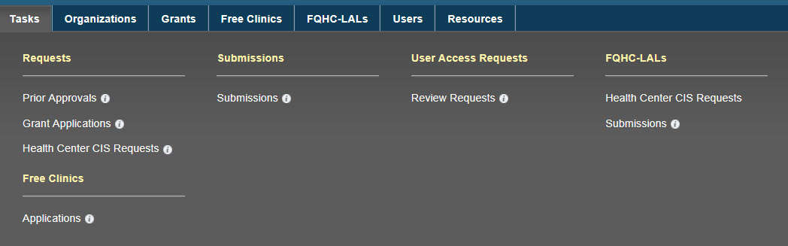
Figure 1: Top Navigation Panel
When you hover over the information icon next to the shortcuts you will see a pop up window with helpful information explaining the shortcut, as well as links to FAQs (Figure 2).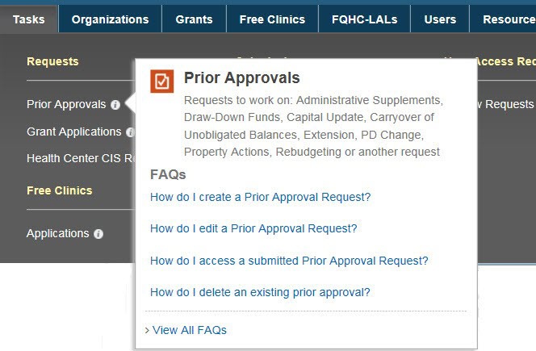
Figure 2: Top Navigation Panel Information Icon

My Tasks Widget
The My Tasks widget (Figure 3) displays a summary count of the following information:

- Total number of pending tasks in green
- Number of late tasks in red
- Number of tasks that are due within 30 days in blue
Clicking on the task number navigates you to the Pending Tasks page where you can work on your tasks.
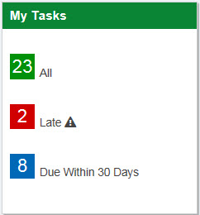
Figure 3: My Tasks Widget

Help Widget

The Help widget (Figure 4) features a rotation of videos to guide you through some of the most commonly asked questions. There are 4 links within the widget that guide you to other resources:
- In the What’s New you can find information about changes and new features to the EHBs.
- HRSA Contacts takes you to the Contact Us page where you will find contact information for the Project Officer (PO) and the Grants Management Specialist (GMS) for all the grants listed in your EHBs Portfolio. Here you will also find contact information for the HRSA Contact Center.
- The FAQs link takes you to a list of Frequently Asked Questions sorted by EHBs topics.
- Click the link to View All Videos to see the list of all the helpful EHBs videos.

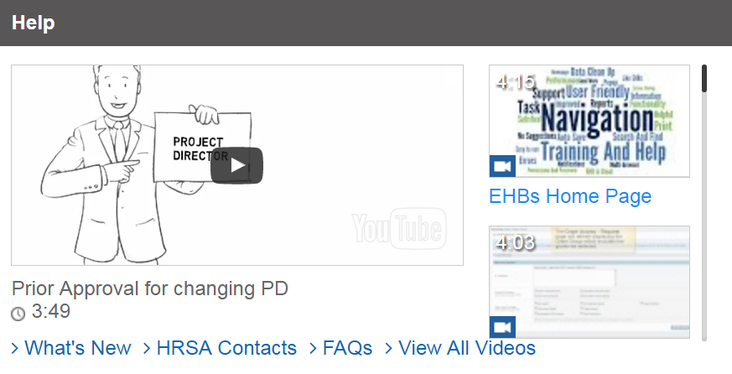
Figure 4: Help Widget

Favorites
The Favorites widget (Figure 5) provides quick navigation to the EHBs pages you use most often, such as Organization and Grant Folders. For your convenience, favorites will be color-coded based on page type. You will be able to pin and un-pin the favorites from the Home Page. By clicking on the pushpin icon, displayed on the top right corner of each favorite block, you can easily unpin items from the widget.
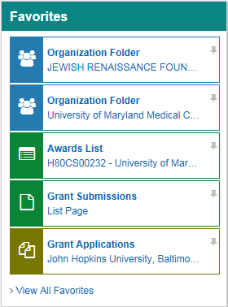
Figure 5: Favorites Widget
To add pages to your Favorites list, click on the Star icon in the bottom right corner of any page you are on, such as an Organization Folder home page (Figure 6). If a page cannot be added as a Favorite to your Favorites list, the Star icon will be white, letting you know that this feature is disabled for the page you are on.
Figure 6: Add Favorite
To manage your Favorites, click on the View All Favorites link below the Favorites list (see Figure 5 above) and you will see the Manage Favorites page. You can pin and unpin items to your Home Page by clicking on the pushpin icons in the left column, “Pin to Home Page” (Figure 7). If the pushpin icon is upright and green, the item will be pinned to your Home Page. If the pushpin icon is horizontal and blue, the item will not be pinned to your Home Page, however you will still be able to access it from your Home Page by clicking on the View All Favorites link. Make sure to click the Save button to save any changes made in the Manage Favorites page.
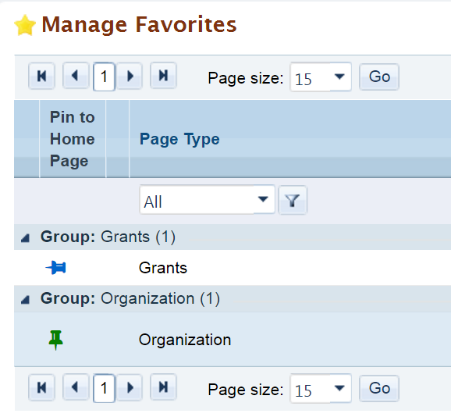
Figure 7: Manage Favorites and Pin to Home Page
Helpful tip: Only five items will be displayed at a time in the Favorites widget of your Home Page. The first five items you add as favorites will automatically be pinned to your Home Page. Note that if you add a sixth item to your favorites, it will not automatically be pinned to your Home Page. You can go to your Manage Favorites page to unpin another item and pin the newest item so that it shows on your Home Page.

Tracking
The Tracking widget (Figure 6) allows you to view the status of your recently submitted items. You can track the status of Applications, Prior Approvals, CIS Request, and other Submissions directly from the Home Page. The six most recently completed items will be listed in this widget.
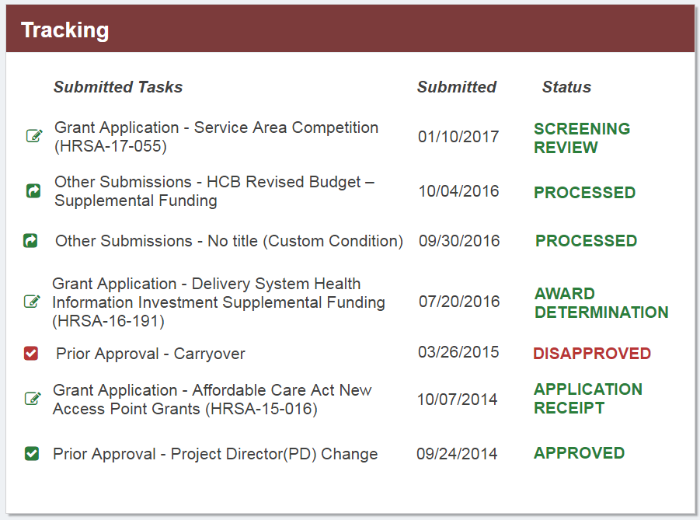
Figure 8: Tracking Widget
Helpful tip: You will be able to see the status of grant applications for all the organizations you are registered to, regardless of whether you worked on the application or not. The submissions displayed in the Tracking widget depend on your grant level privileges. This means that you will only be able to see the status of submissions for which you have the correct grant level privileges.

Recently Accessed
The Recently Accessed Home Page widget (Figure 7) will allow you to navigate to tasks and areas in EHBs you recently worked on, or started but did not complete. Items in this list will be added automatically as you work in EHBs. Item types will be color coded for easier identification.
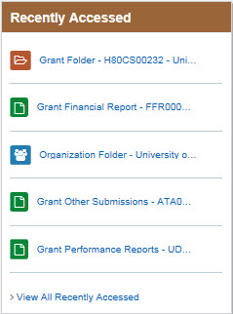
Figure 9: Recently Accessed Widget
Helpful tip: The Recently Accessed widget will show different items than the items listed in the Tracking widget. The Recently Accessed widget lists all items that you have recently accessed in the EHBs, such as a task that you are working on and have not yet completed, or a read-only page such as the Organization Home Page. The Tracking widget on the other hand only displays completed tasks as they go through the HRSA review process. The Tracking widget will not display folders such as the Organization Folder Home or the Grant Folder Home.

Resources Tab
The Resources Tab (Figure 8) is added to the top Navigation Panel of the EHBs Home Page. In this tab, you will find all EHBs Help Videos and EHBs Help content, such as Frequently Asked Questions (FAQs).
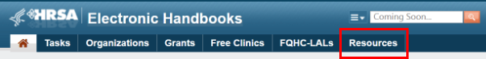
Figure 10: Resources Tab

Getting Started
The Getting Started page is displayed to new users when they first login and to users who have not logged in for 90 days or more. The Getting Started page can also be accessed by clicking on the Resources tab and then clicking on “Getting Started with the EHBs” (Figure 9).
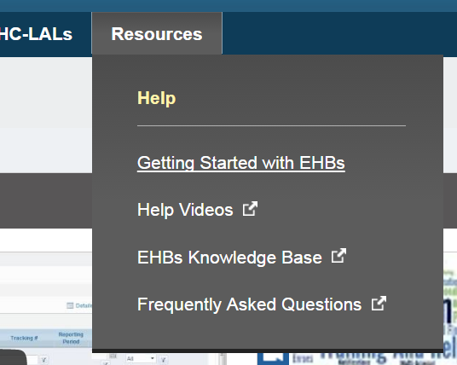
Figure 11: Resources Link to Getting Started with EHBs
The Getting Started page (Figure 10) guides users through the pre-requisites of creating an account, checking browser settings and registering to an organization. It also helps users get everything organized with their EHBs access by guiding them through setting up their EHBs access to additional organizations, grants and applications.
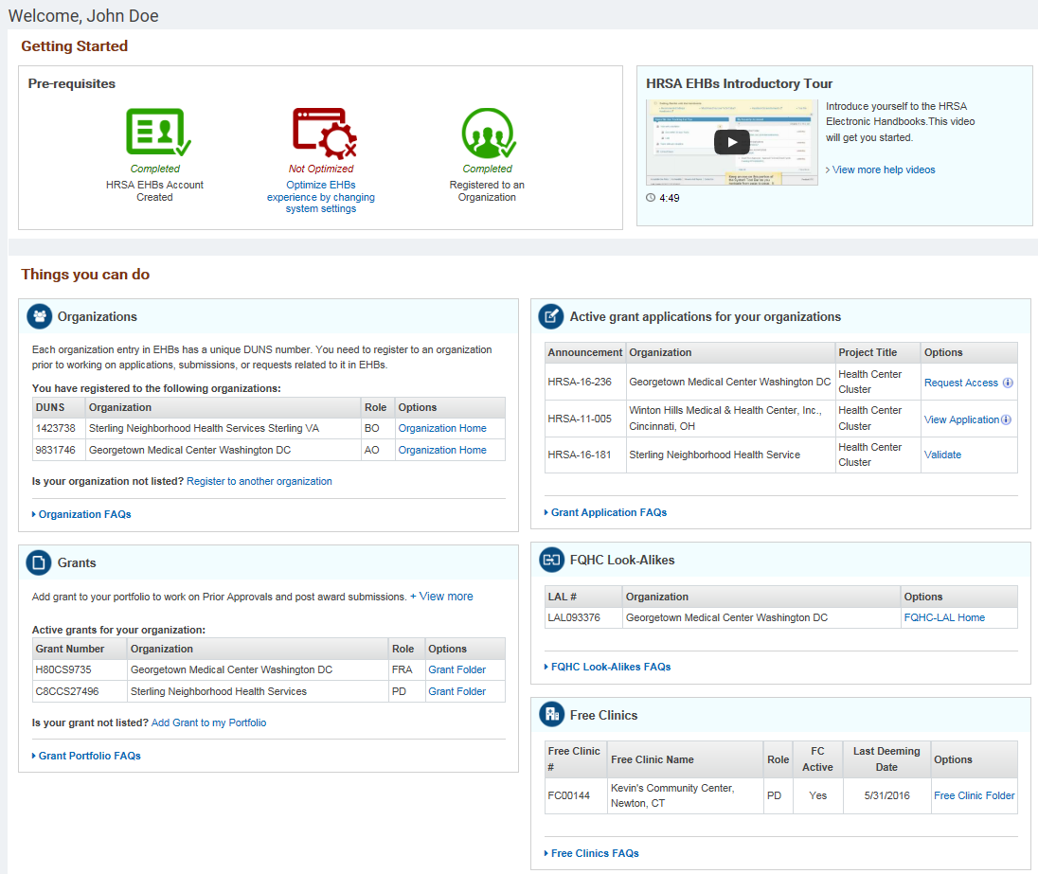
Figure 12: Getting Started Page

Contacts
You can access the Contact Us section by clicking on the HRSA Contacts link in the Help Widget (Figure 11). The Contact Us section now includes Project Officer (PO) and Grant Management Specialist (GMS) contact information for all the grants listed in your EHBs Portfolio (Figure 12).
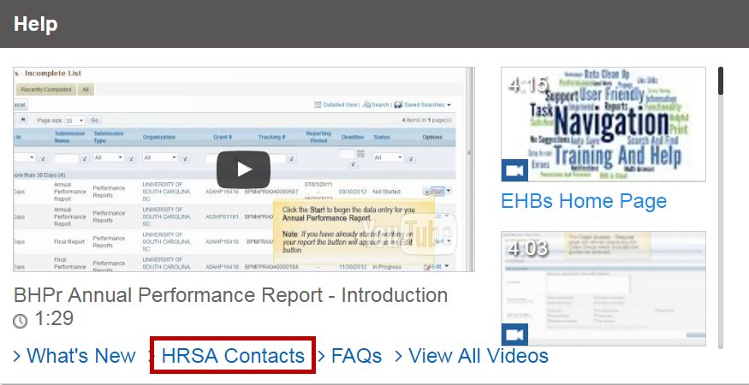
Figure 13: HRSA Contacts link
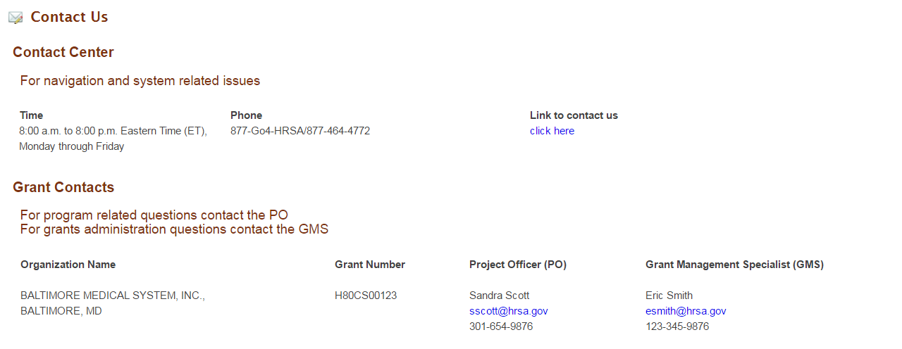
Figure 14: Contact Us
For more information on the Home Page and Navigation or for any EHBs related assistance, contact the HRSA Contact Center by calling Toll Free: (877) Go4-HRSA; (877) 464-4772 or submitting a ticket here: http://www.hrsa.gov/about/contact/ehbhelp.aspx

